
OPEN HOUSE

February 7, 2011

Mr. Bob Smith
XYZ Realtors
1000 Sepulveda Blvd
Los Angeles, CA 00000

Dear Bob,

We would like to introduce ourselves to you. Our "top originating" mortgage team has been successfully closing mortgage loans in the South Bay for nearly 18 years. We take our relationships with our Realtor partners and clients very seriously. We are relationship lenders focused on meeting and exceeding the expectations of our clients.

We have attached 3 testimonial letters from our Realtor partners and clients to share with you "what our clients are saying about us". We have selected you specifically as someone we would welcome the opportunity to meet with. We would welcome the opportunity to find out more about your success in the real estate arena and see if there might be some ability to share some ideas of how we can be more successful together in 2011.

We will be contacting you within the next week to schedule a 15 minute meeting to see how we might be able to assist you with growing your business this next year.

We look forward to the opportunity.

All the best,

Cindy Ertman & Linda Buchanan
The Ertman-Buchanan Team
Your Mortgage Solution Specialists

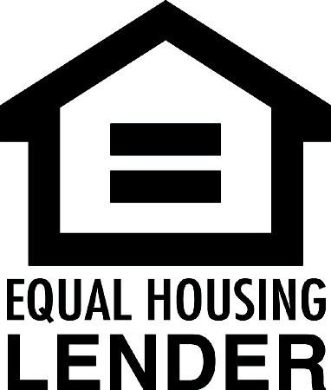
California Department of Real Estate – real estate broker license # 01818035

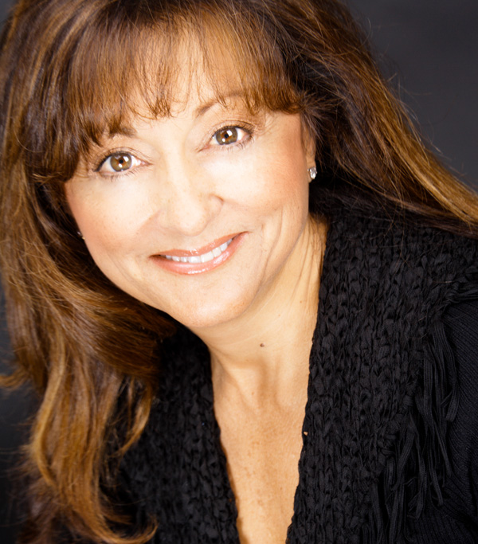
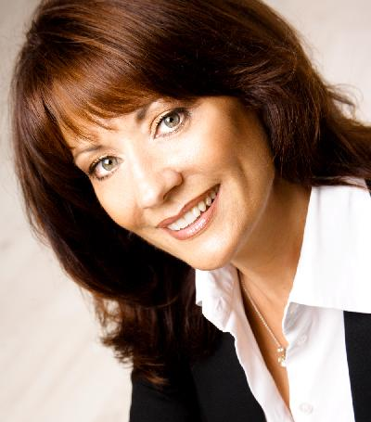
CINDY ERTMAN
Direct: 310.796.5600 ext. 350
Email: certman@rpm-mtg.com
Website: www.CaliforniaHomeLoans.com
CA DRE # 00772133 • NMLS #330850

3500 Sepulveda Blvd., Ste. E
Manhattan Beach, CA 90266

LINDA BUCHANAN
Direct: 310.897.8789
Email: lbuchanan@rpm-mtg.com
Website: www.CaliforniaHomeLoans.com
CA DRE # 01214104 • NMLS #303528

3500 Sepulveda Blvd., Ste. E
Manhattan Beach, CA 90266

